**Lab Assignment 8**

This is applications which uses server side mashup and create a web application to access these services through REST Services. The output can either be JSON or XML format.

**Wire Frames:**

**Interest Calculator Page:**

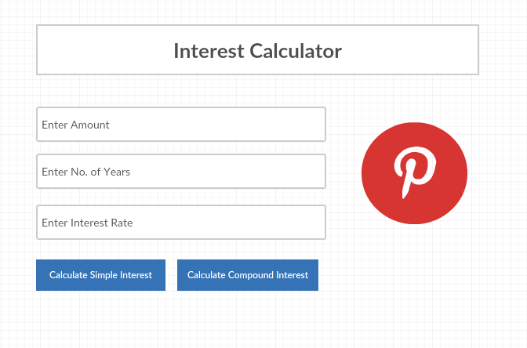

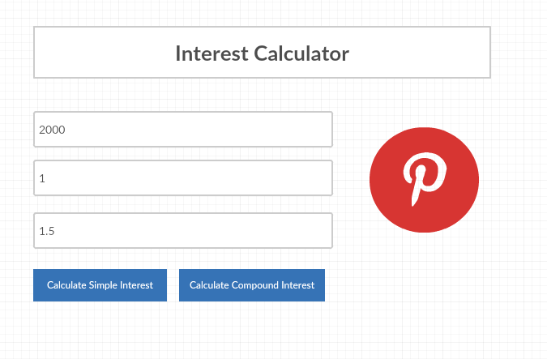

**Application Pages:**

**Interest Calculator Page:**

This is the interest calculator page where you enter amount, no. of years and time and if you click on ‘Calculate Simple Interest’ button then it sends the REST call to the server and calculate Simple Interest and generate the output in the form of XML or JSON. To calculate Compound Interest click on ‘Calculate Compound Interest’ button then again a REST call is send to the server and calculates the Compound Interest and generates the output in the form of XML orJSON.

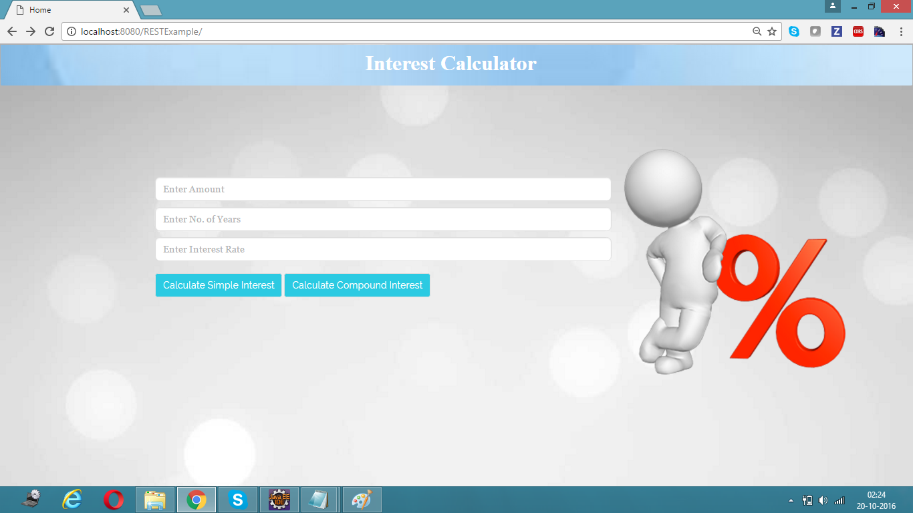

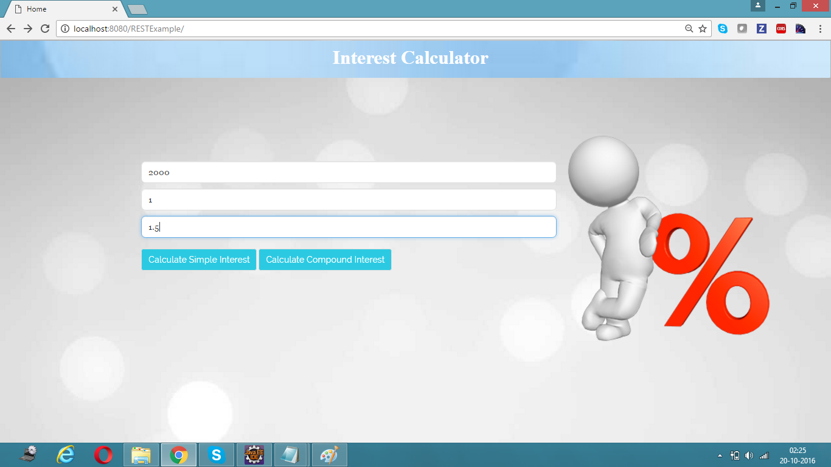

**Simple Interest Output (JSON):**

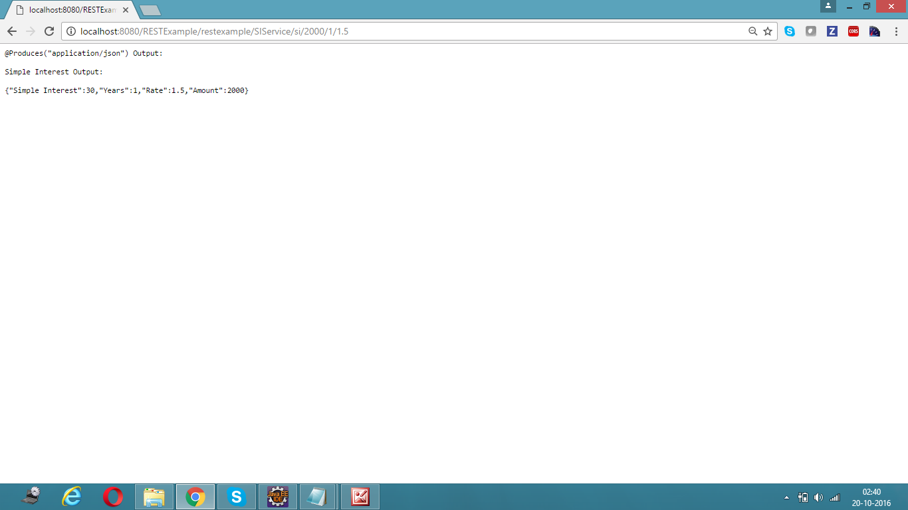

**Simple Interest Output (XML):**

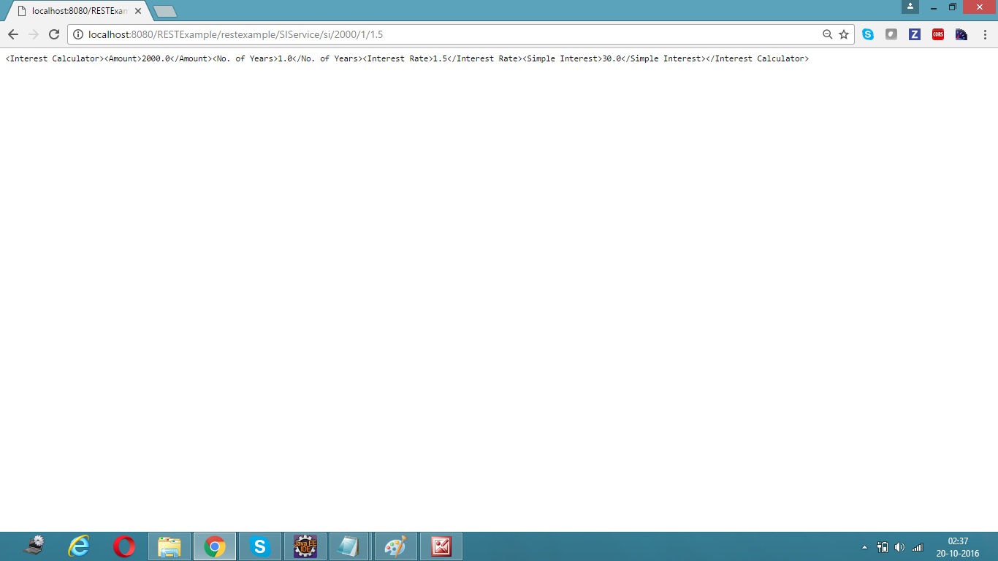

**Compound Interest Output (JSON):**

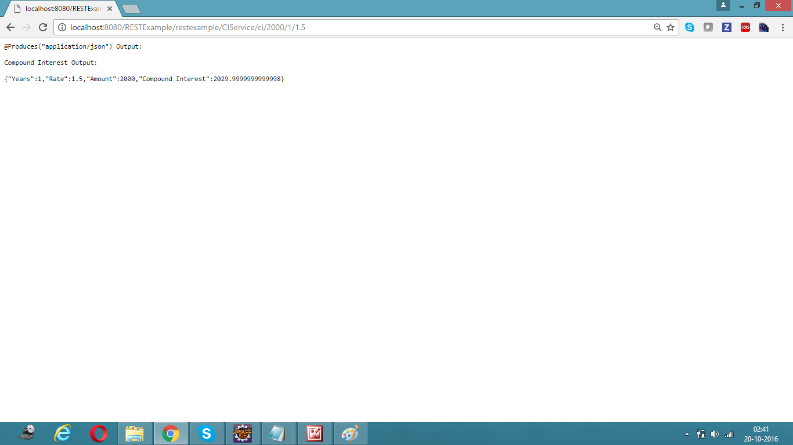

**Compound Interest Output (XML):**

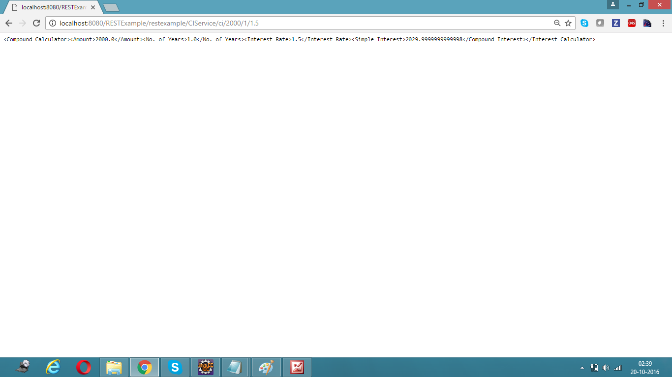

**JUnit Test Cases:**

**Simple Interest Success Test Case:**

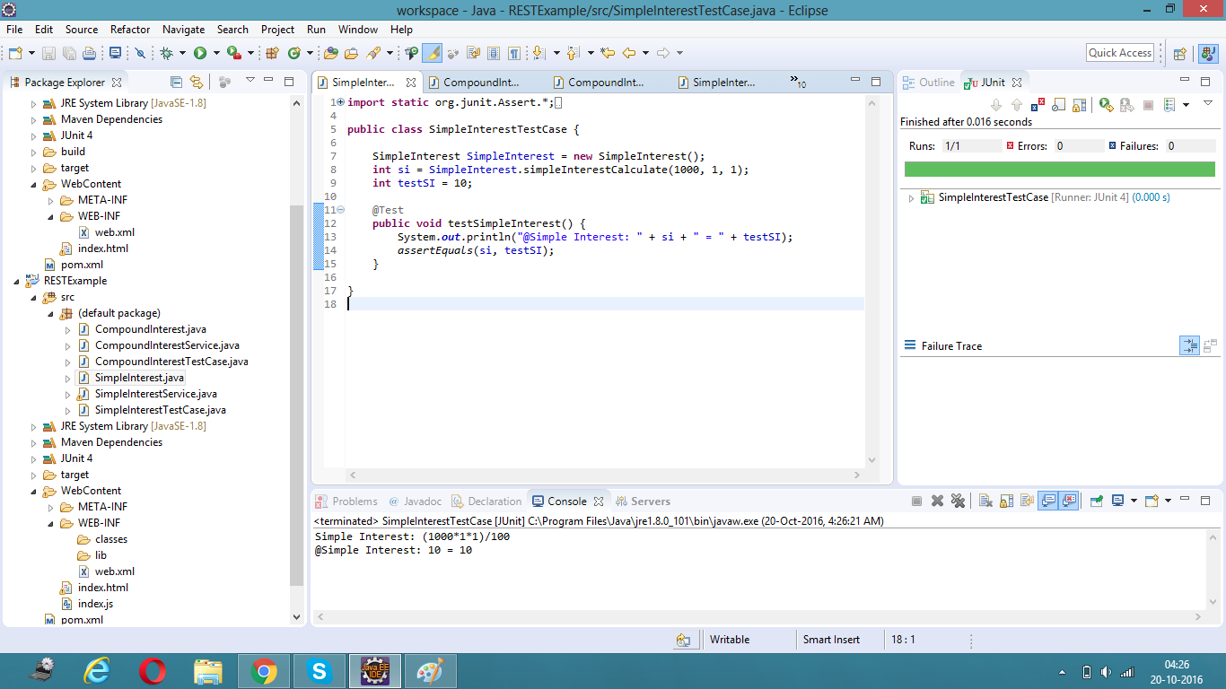

**Simple Interest Failure Test Case:**

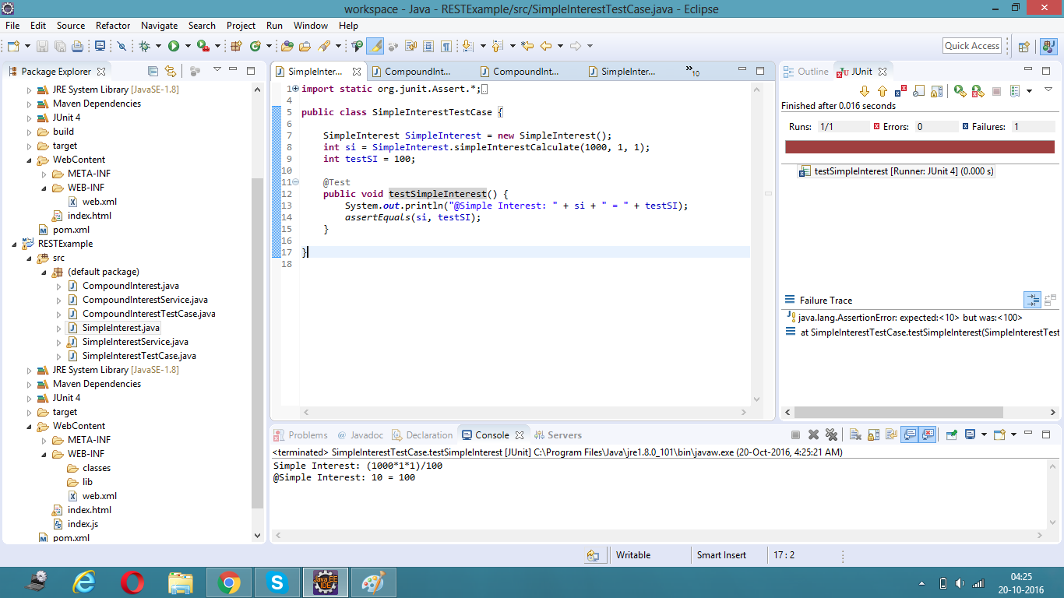

**Compound Interest Success Test Case:**

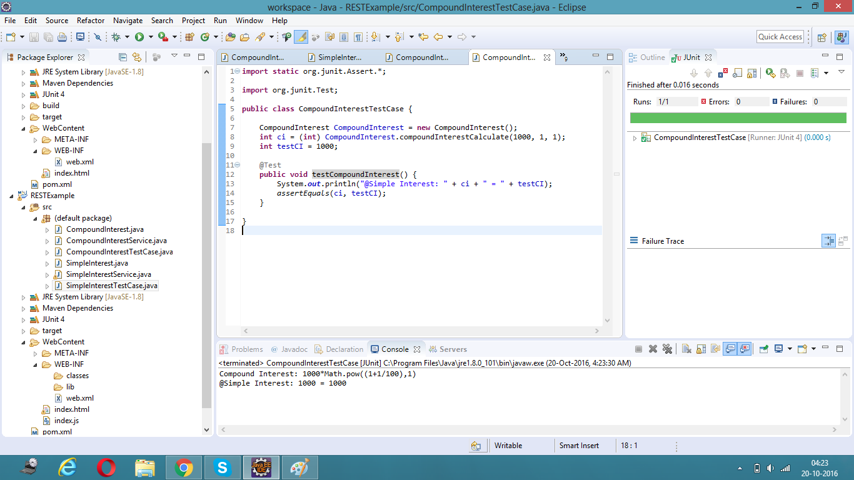

**Compound Interest Failure Test Case:**

